**Membership Modules**

1. Login

2. Dashboard

3. Masters

4. Membership

**Modules Description**

**1. Login Module**

**1.1. Login Roles**

There are five different user roles implemented:

**1.1.1 Union Role**

Unioncan manage everything at admin panel, its acts like **Super Admin.**

Union can add Union branches, Company branches and members.

Union can assign modules to roles.

**1.1.2 Union Branch Role**

Union Branch can view their dashboard

Union branch can manage members of their company branches.

**1.1.3 Company Role**

Company can view their dashboard

Union branch can manage members of their company branches.

**1.1.4 Company Branch Role**

Company branch can view their dashboard

Company branch can manage members of their down company branches.

**1.1.5 Member Role**

Member can view their dashboard

Member can sign up and update their profile.

**1.2 Login Features:**

**1.2.1 Login**

**Login URL:** <http://membership.graspsoftwaresolutions.com/en>

**Screenshot:** 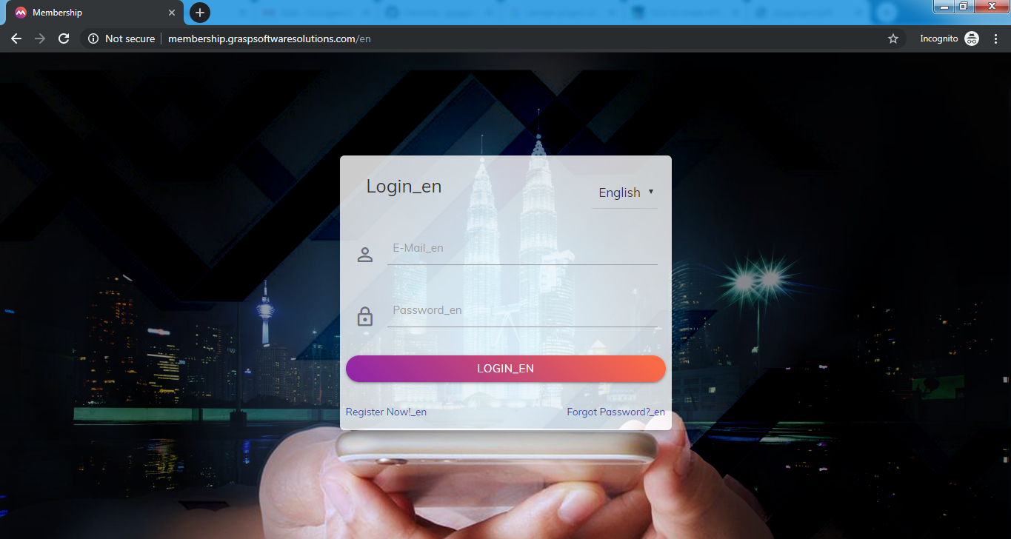

**Union Login:**

Email: [union@gmail.com](mailto:union@gmail.com)  
Password: 12345678

**Union Branch login:**

Email: [unionbranch@gmail.com](mailto:unionbranch@gmail.com)  
Password: 12345678

**Company login:**

Email: [company@gmail.com](mailto:company@gmail.com)  
Password: 12345678

**Company Branch login:**

Email: [companybranch@gmail.com](mailto:companybranch@gmail.com)  
Password: 12345678

**Member Login:**

Members can register/Signup

Register link: <http://membership.graspsoftwaresolutions.com/en/register>

Once the member submitted register form, member will receive mail to registered email address.

Mail details:

Email & password will be sent.

**Test Cases:**

1. Correct credentials.

Input: Email: [union@gmail.com](mailto:union@gmail.com)  
 Password: 12345678

Result: User will be redirected to dashboard.

2. Wrong credentials.

Input: Email: [test@gmail.com](mailto:test@gmail.com)  
 Password: 00000000

Result: These credentials do not match our records.

**1.2.1 Forgot password**

User can reset password.

Link: <http://membership.graspsoftwaresolutions.com/en/password/reset>

Once the user submitted form, user will receive mail.

Mail details:

Reset password link will be sent.

**1.2.2 Change password**

If the user logged in, User can change the password.

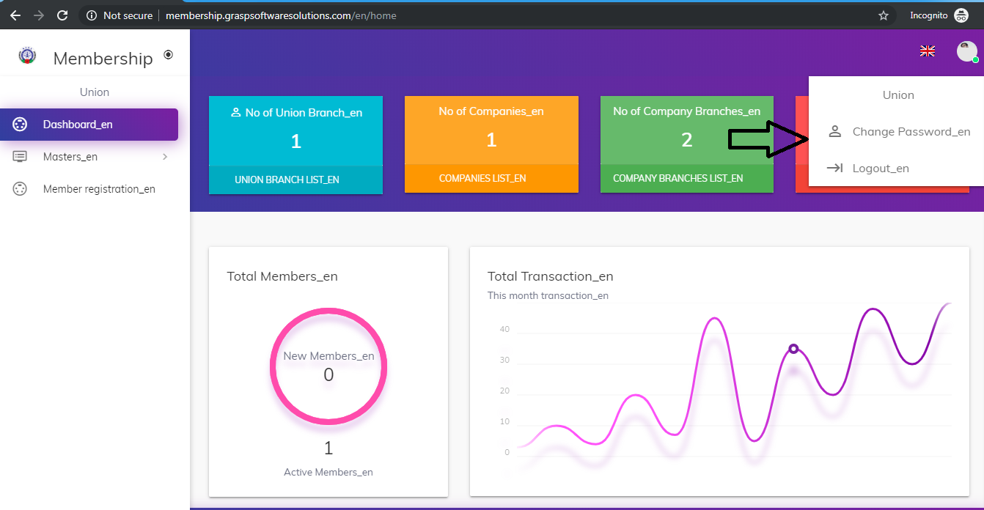

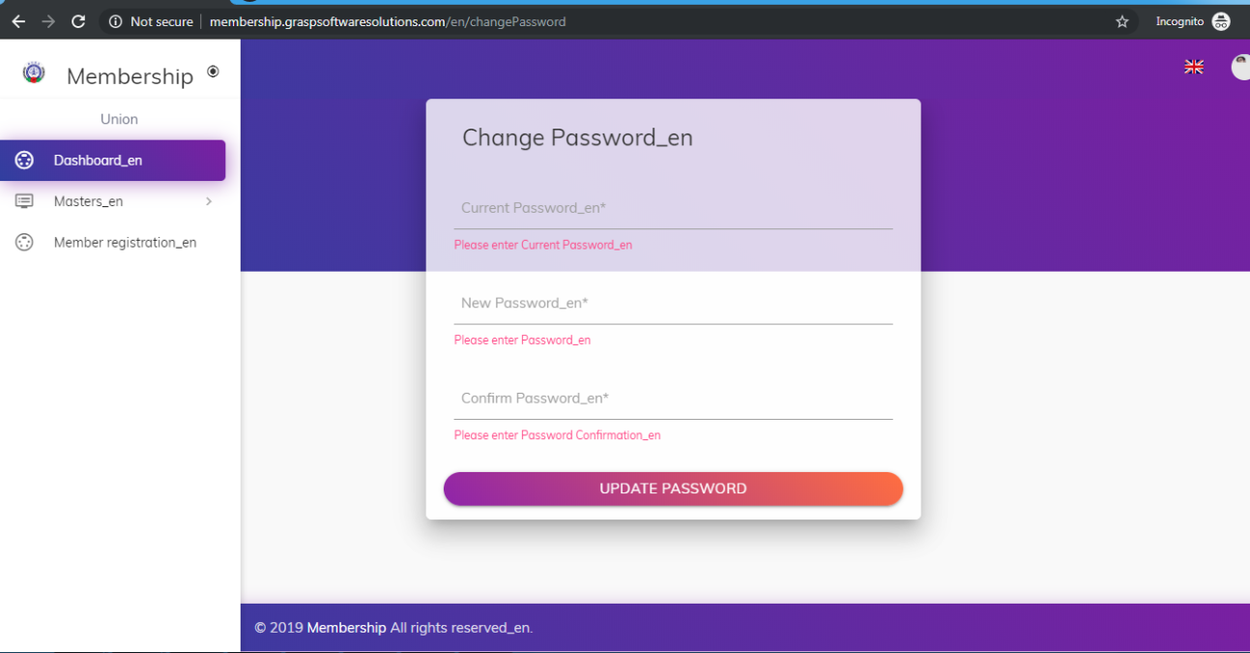

**1.2.3 Assigning Modules to Roles:**

Union can edit roles and they can assign modules to roles.

Screenshot:

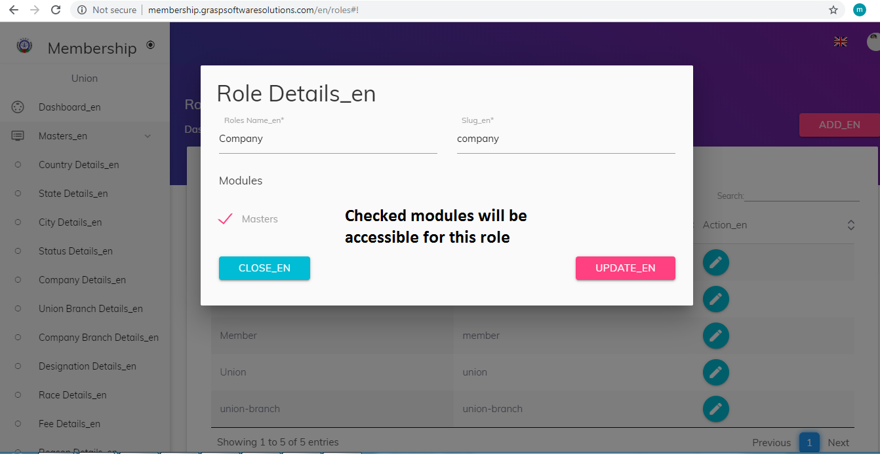

**2. Dashboard Module:**

**2.1. Union Dashboard**

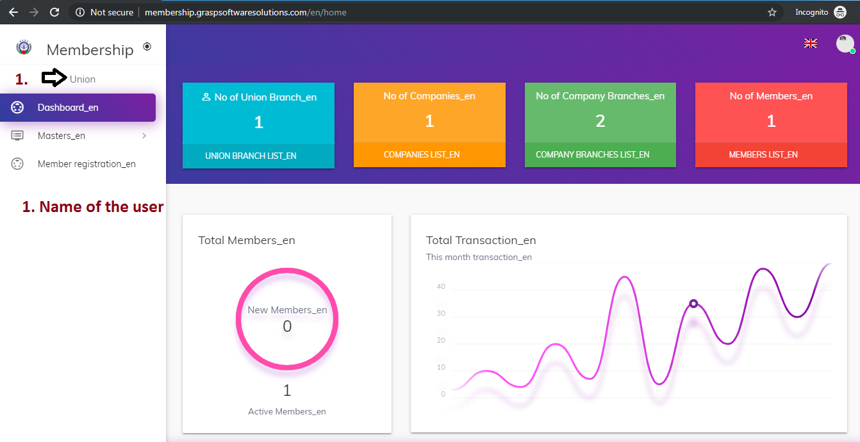

**Dashboard contents:**

1. **No of Union Branches**

Union branches count without head branch

1. **No of Companies**

Head company branches count

1. **No of Company Branches**

Company branches count with head branch

1. **No of Members**

Overall members count including new members.

**2.2. Union Branch Dashboard**

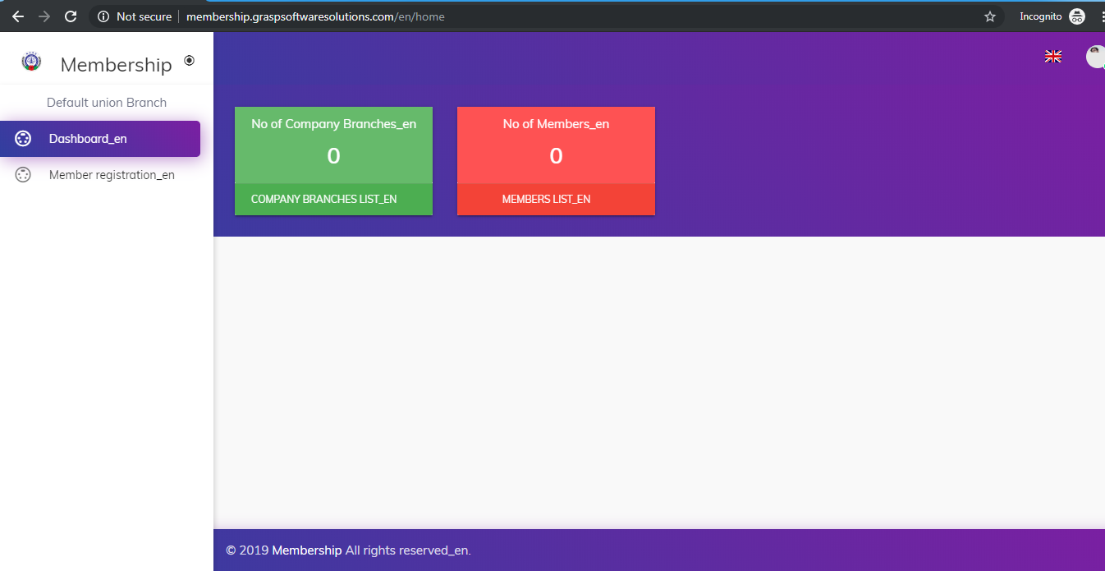

**Dashboard contents:**

1. **No of Union Branches**

Union branches count without head branch

1. **No of Members**

Overall members count including new members

**2.3. Company Dashboard**

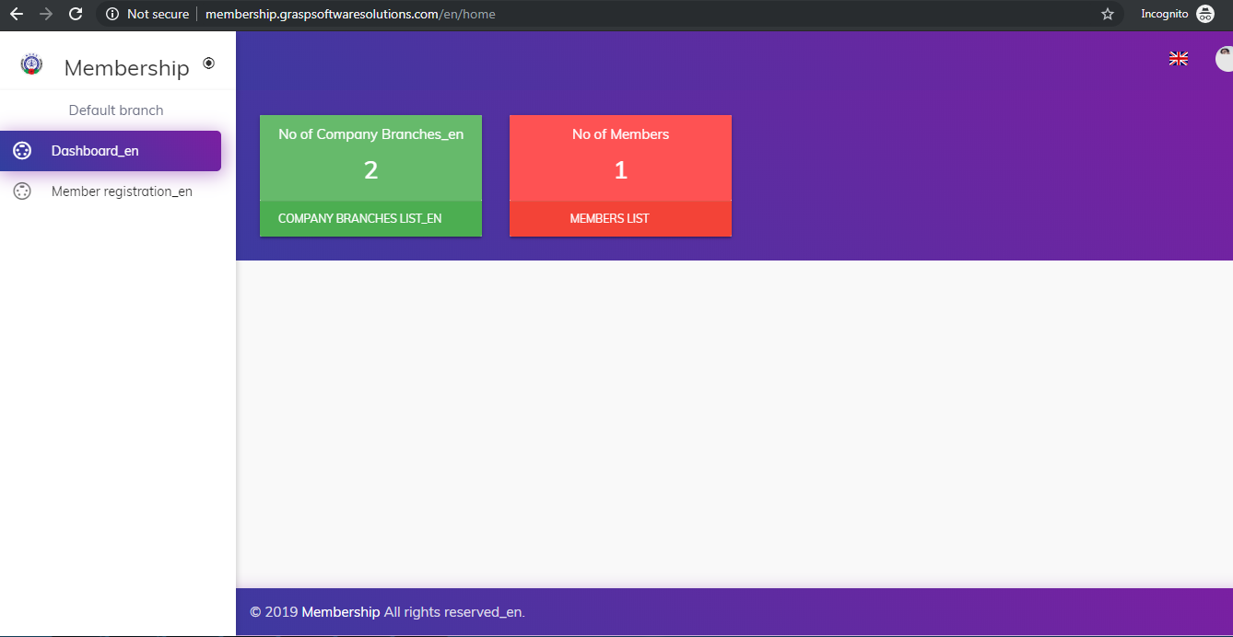

**Dashboard contents:**

1. **No of Union Branches**

Union branches count without head branch

1. **No of Members**

Overall members count including new members

**2.4. Company Branch Dashboard**

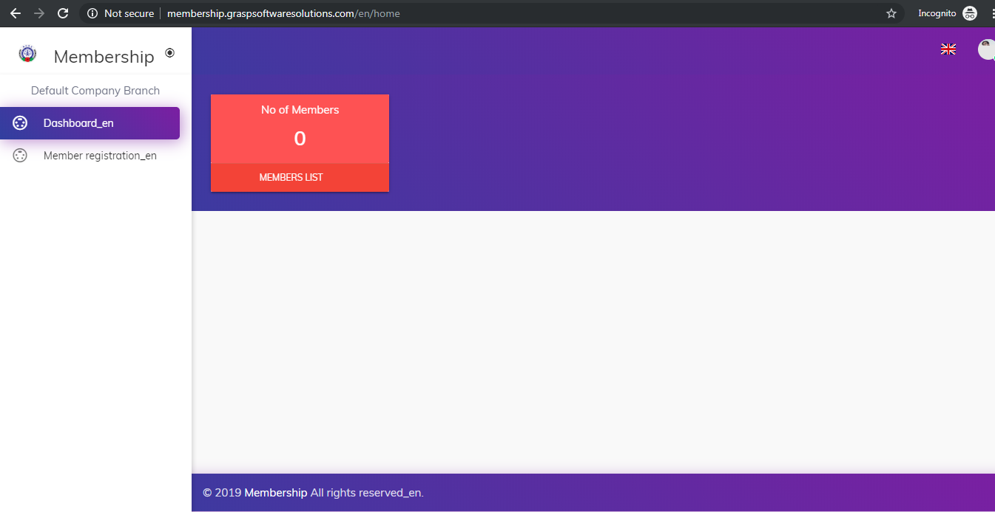

**Dashboard contents:**

1. **No of Members**

Overall members count including new members

**3.Master Module**

This module is designed to be used to stores the user's basic information and it contains 12 subcategories that are used to stores the user's basic information. This Allows Union user’s to maintain, update, view and delete the corresponding records.

12 Subcategories are,

* Country Details
* State Details
* City Details
* Status Details
* Company Details
* Union Branch Details
* Company Branch Details
* Designation Details
* Race Details
* Person Title Details
* Relation Details
* Form Type Details

1.Country Details

The country details helps to store ,update and delete the country details

**1. Country List [English Version]**

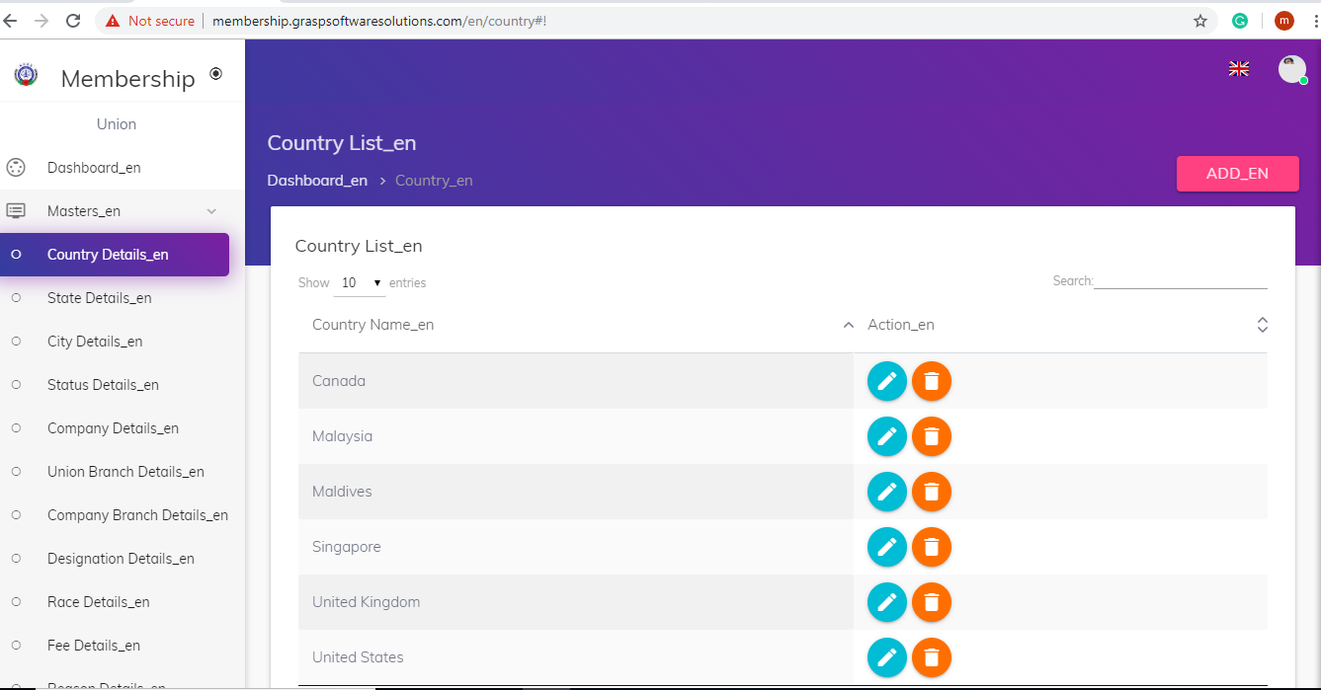

**Add Country**

Enter the Country name here it will check the exists of the country name, If the country is not exists then the country name will be stored.

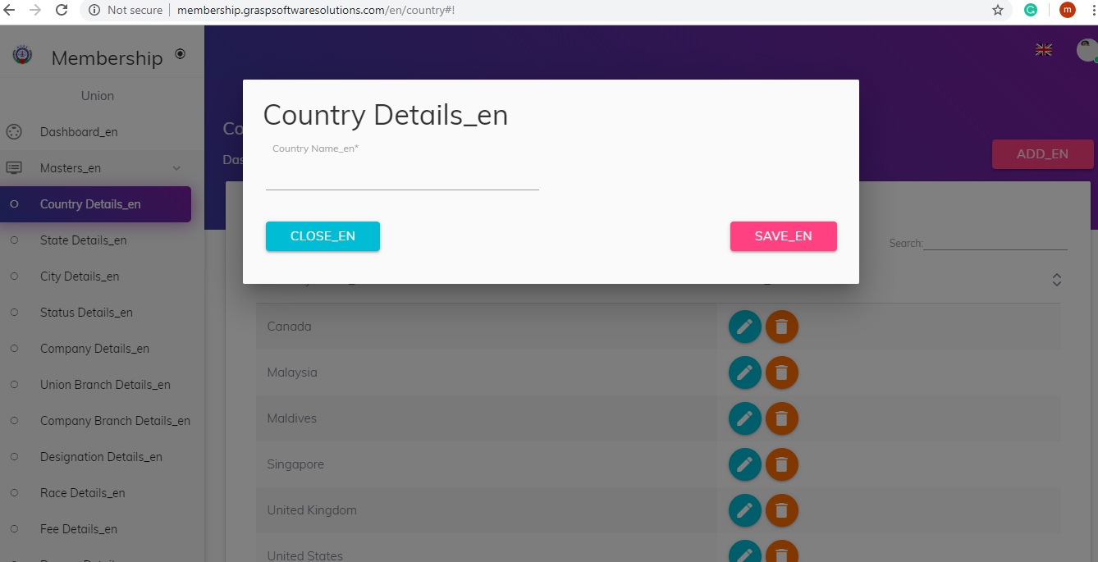

**Country**

**1.Test Case 1 :**

Country Name : America

Result : The Country name is saved successfully, The page will be redirected to Country List page

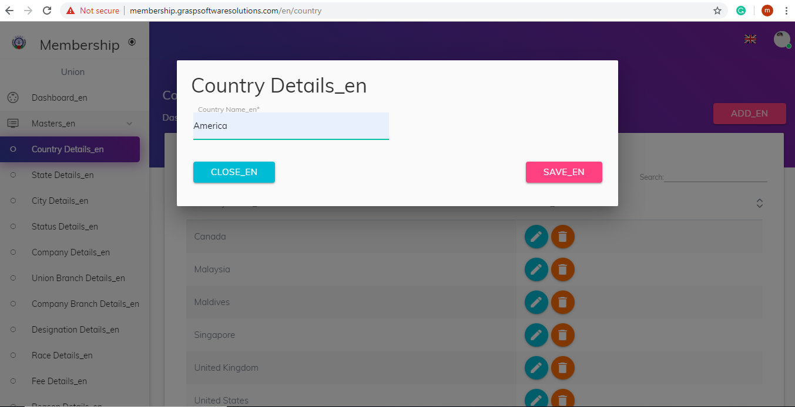

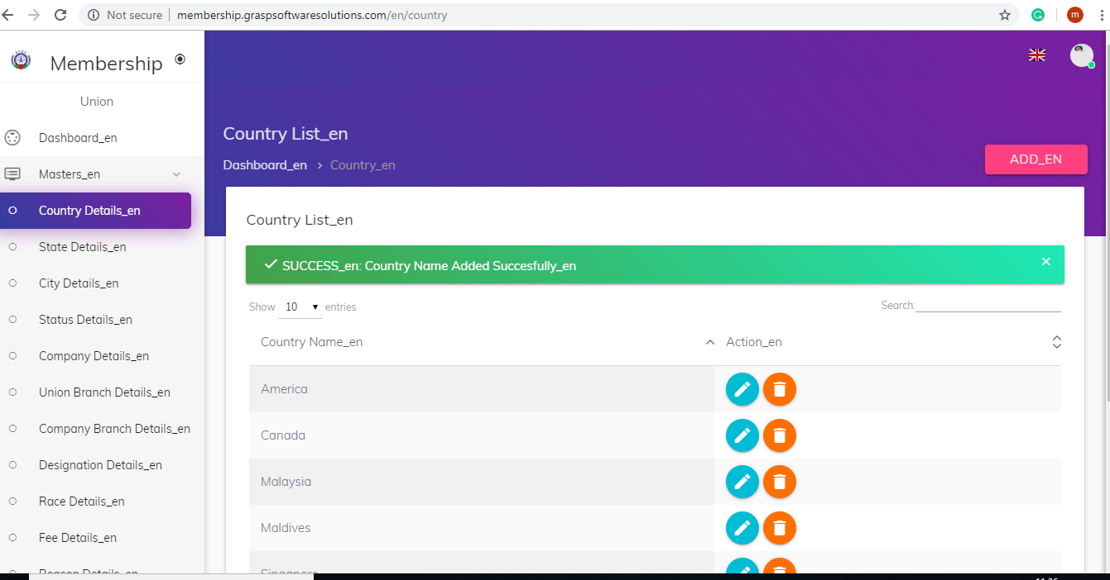

**Exists Check**

**1.Test Case 2 :**

Country Name : America , If the Country Name is in the country list, It will show Country Name is Already Exists.

Result : If the Country Name is in not the country list, It will be added to the country list.

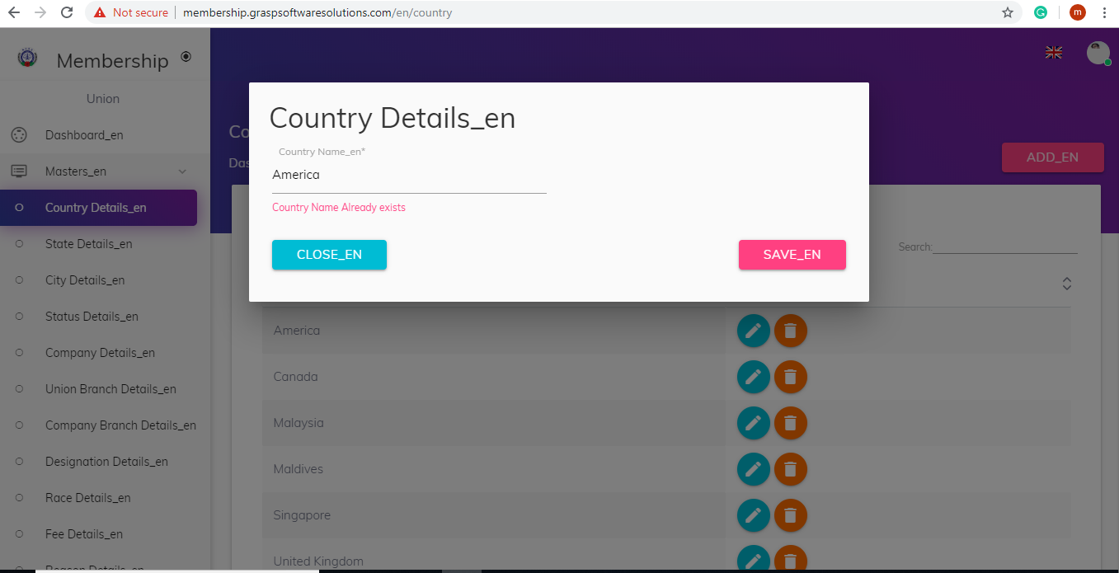

**Required Fields Check**

**1.Test Case 3 :**

Country Name : Required Field

Result : If the required fields are satisfied , the country name will be stored.

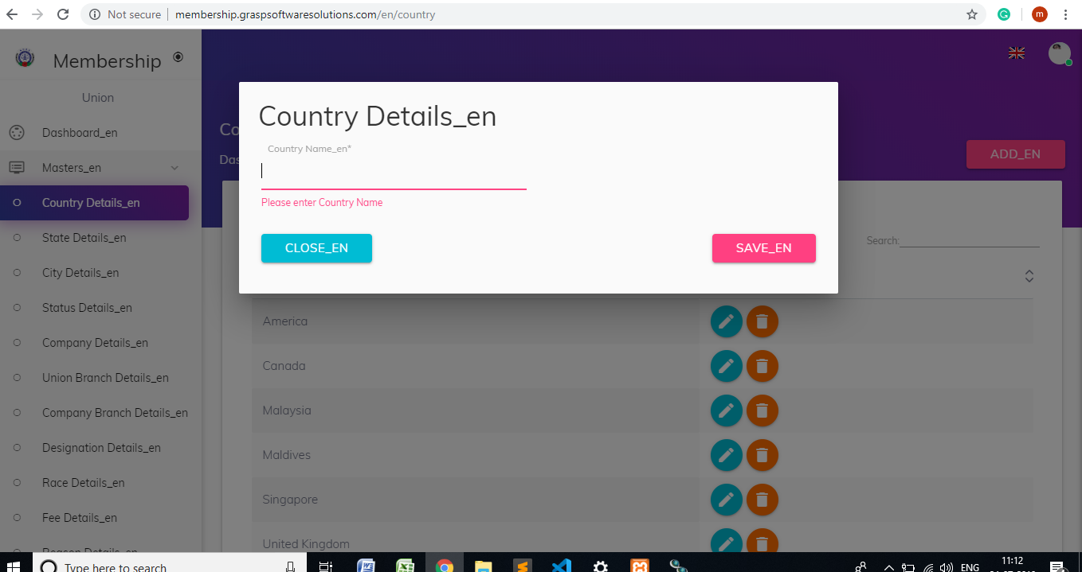

**Update Country**

User can update the country name whenever they want.

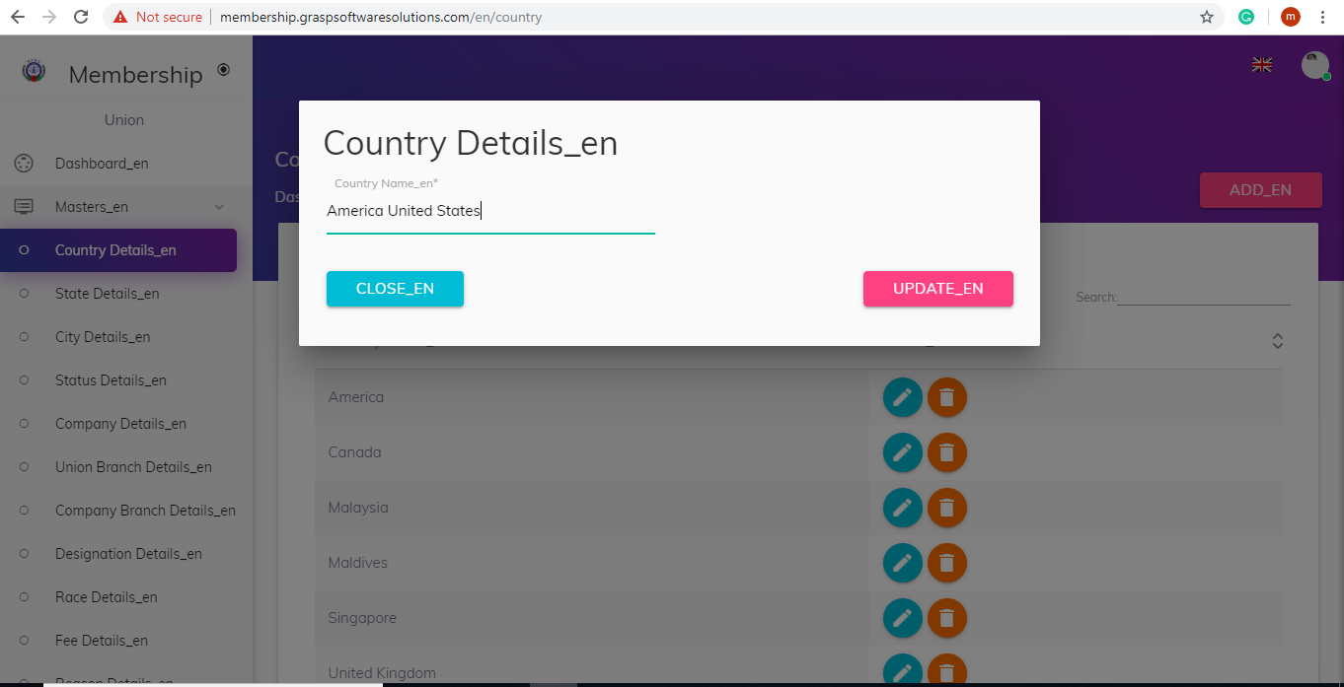

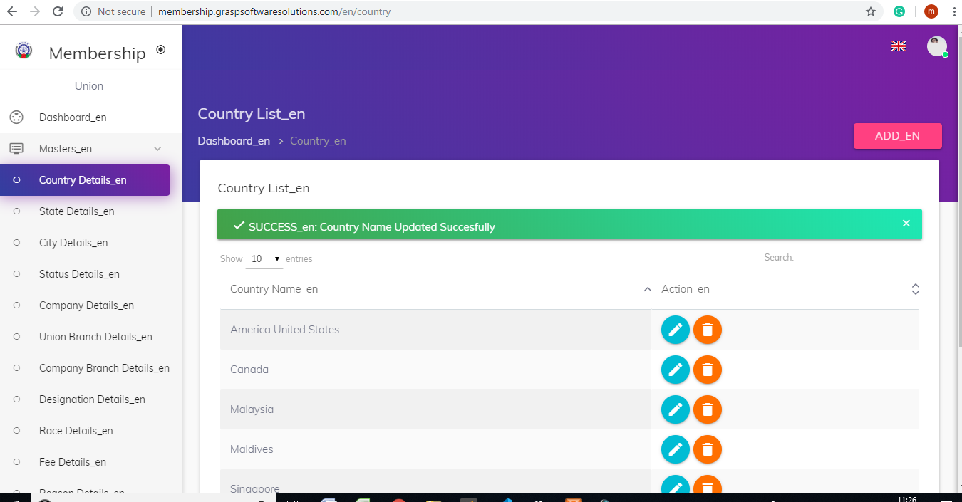

**Delete Country**

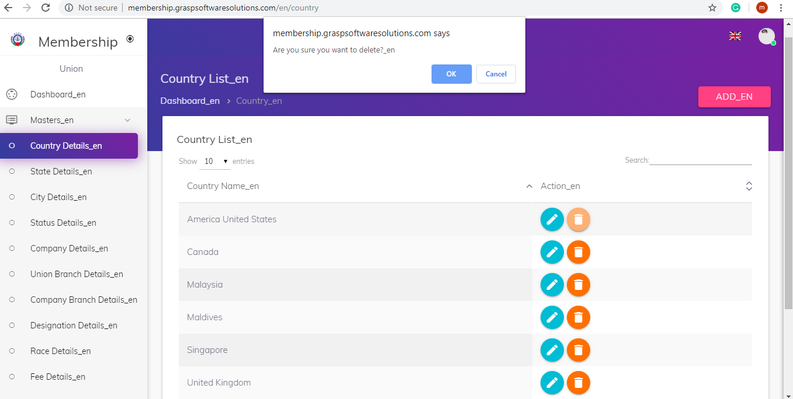

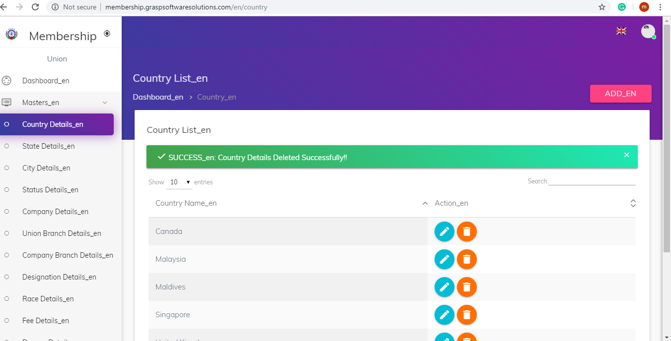

After deleting the company the page will be redirected to Country List page.

**2.State Details**

The State details helps to store, update, View and delete the State details.

**1.State List(View)**

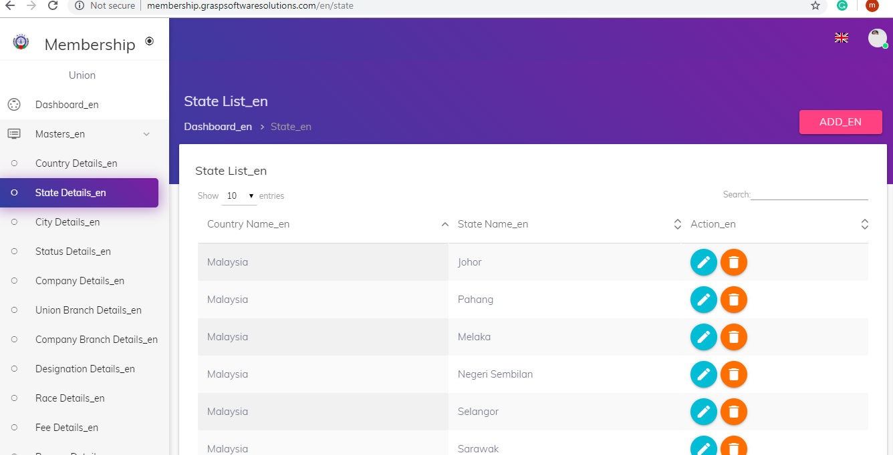

**2.Add State**

**1.Test Case 1 :**

Country Name : America

Default Country : Malaysia

State Name : Johor

Result : The State name is saved successfully, The page will be redirected to State List page.

**2.Test Case 2 :**

**Unique Check** : State Name to the particular Country Name

State Name : Johor, If the State name is in the state list , It will show State Name is Already Exists.

Result : If the state Name is in not the state list, It will be added to the state list.

**1.Test Case 3 :**

**Required Fileds** : Country Name, State Name

Result : If the required fields are satisfied , the state name will be stored.

Add :

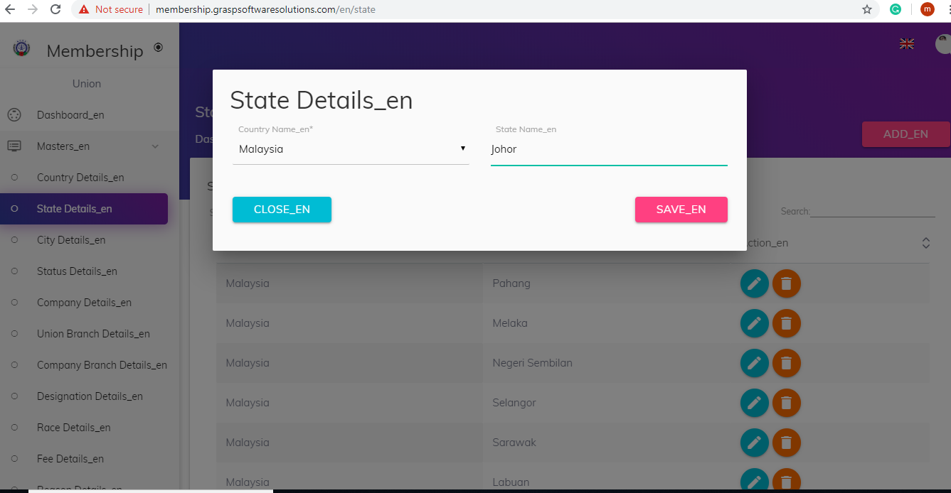

**Update and Delete.**

This allows user to update and delete the records as like the country update and delete.

**3.City Details**

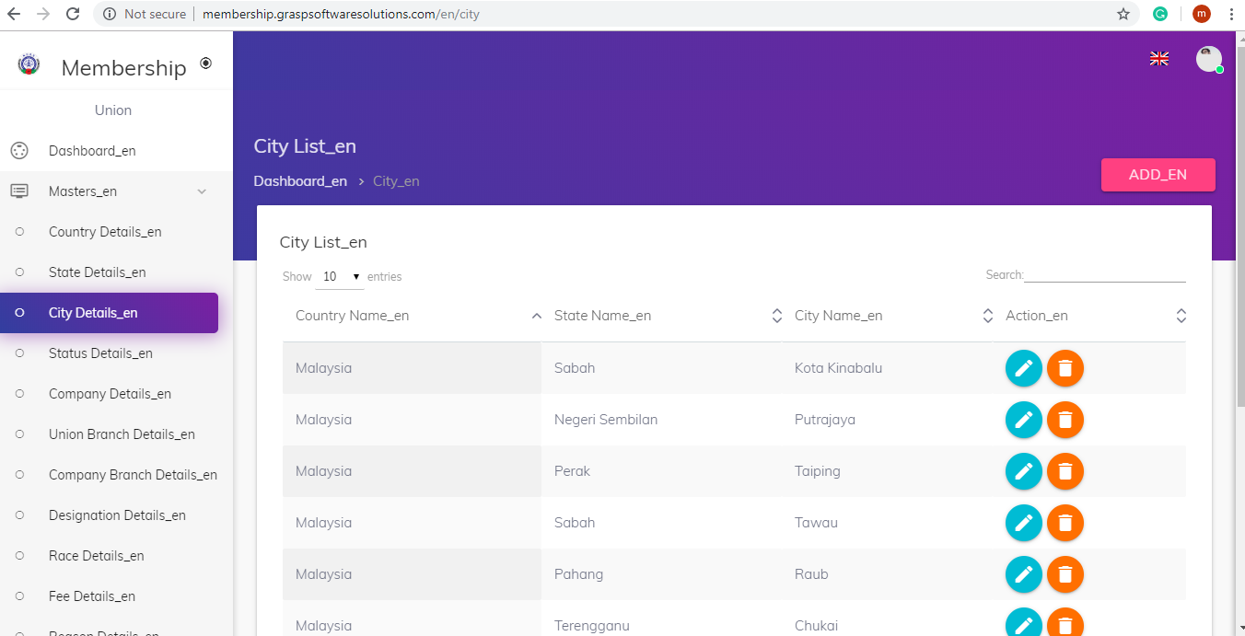

**City Save**

**Test Case 1 :**

Country Name : Malaysia

Default Country : Malaysia

State Name : Johor

City Name : Kota Kinabalu

Result : The City name is saved successfully, The page will be redirected to City List page

**Test Case 2 :**

**Unique Check** : State Name, City Name to the particular Country Name

City Name : Johor, If the City name is in the city list , It will show City Name is Already Exists.

Result : If the city name is in not the city list, It will be added to the city list.

**Test Case 3 :**

**Required Fileds** : Country Name, State Name, City Name

Result : If the required fields are satisfied , the state name will be stored.

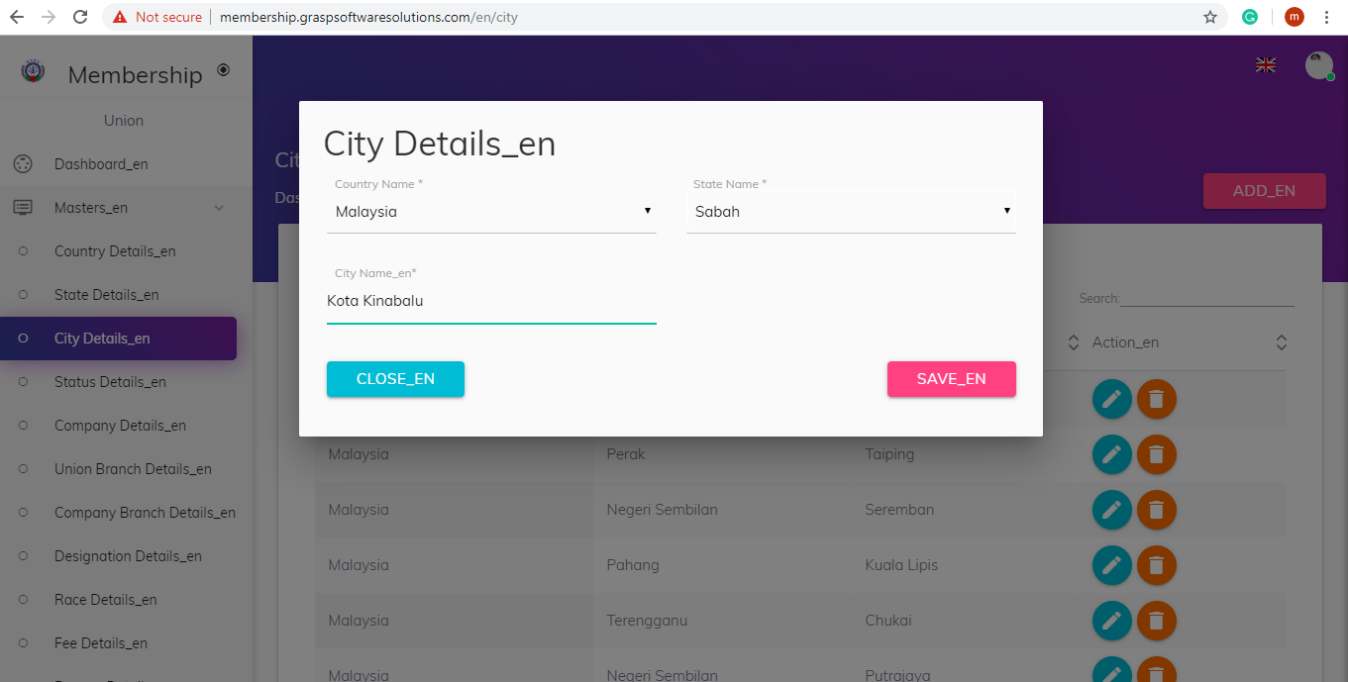

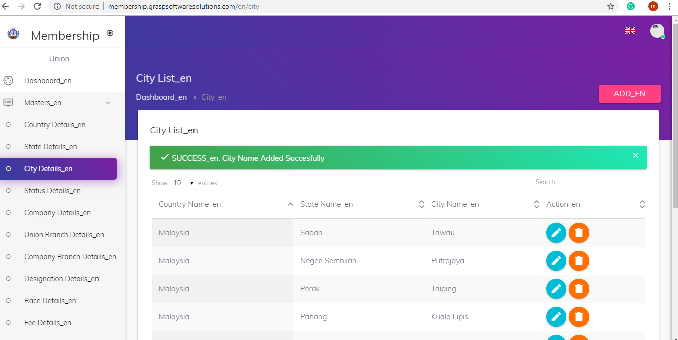

**City Update and Delete.**

This allows user to update and delete the records as like the country update and delete.

**4.Status**

The Status details helps to store, update, View and delete the State details.

**Status List View**

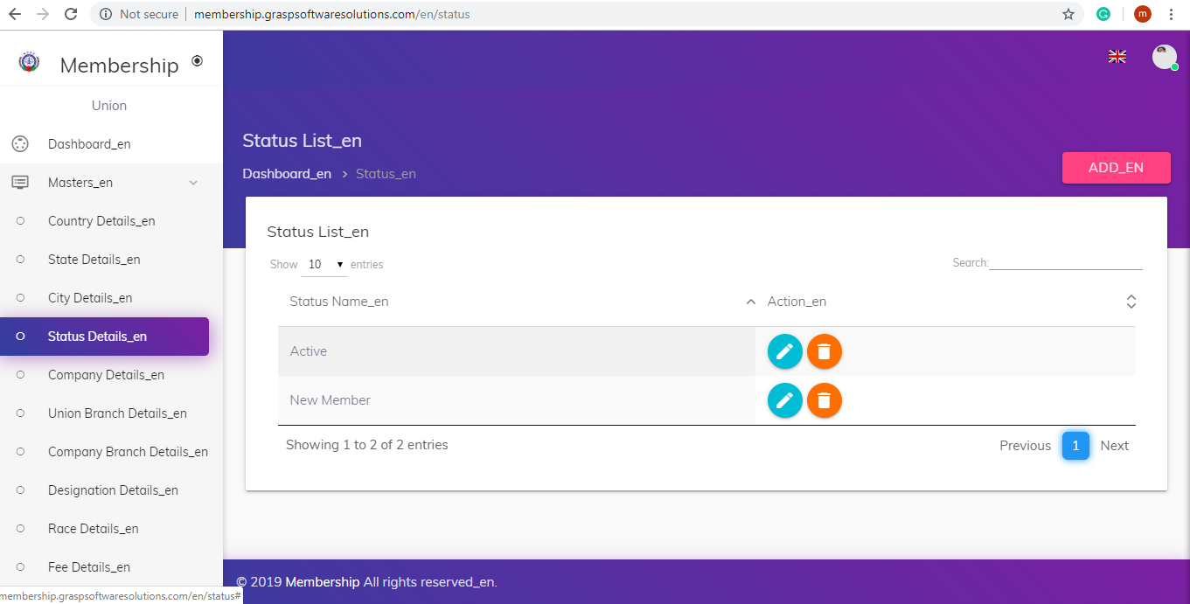

**Add Status**

**Test Case 1 :**

Status Name : Defaulter

Result : The status name is saved successfully, The page will be redirected to Status List page

**Test Case 2 :**

**Unique Check** : Status Name

Status Name: Defaulter, If the status name is in the status list , It will show status name is Already Exists.

Result : If the status name is in not the status list, It will be added to the status list.

**Test Case 3 :**

**Required Fileds** : Status Name

Result : If the required fields are satisfied , the status name will be stored.

Add Status

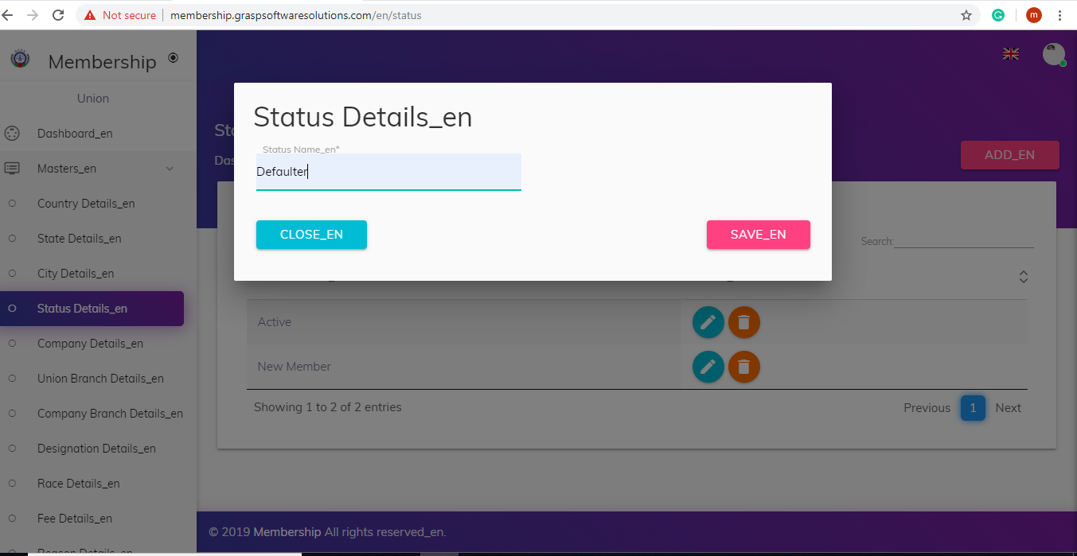

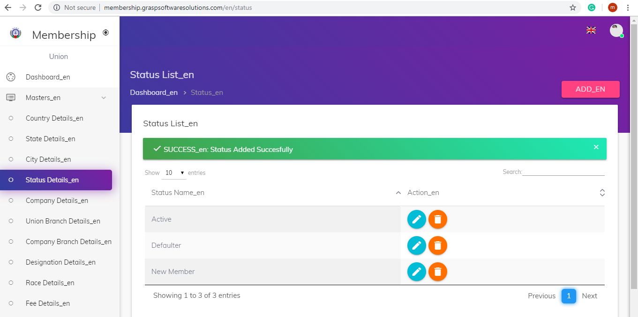

**Status Update and Delete.**

This allows user to update and delete the records as like the Status update and delete.

**5.Company Details**

The **Company** details helps to store, update, View and delete the company details.

**Company List View**

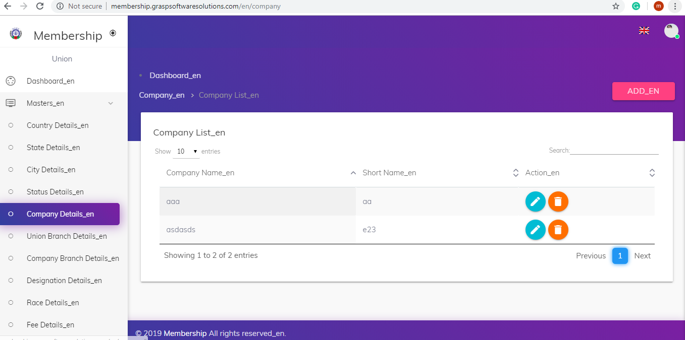

**Add Status**

**Test Case 1 :**

Company Name : Bizsoft solutions

Short Code : BBS

Head of the Company :

Result : The Company name is saved successfully, The page will be redirected to Company List page

**Test Case 2 :**

**Unique Check** : Company Name

Company Name: Bizsoft solutions, If the company name is in the company list , It will show company name is Already Exists.

Result : If the company name is in not the company list, It will be added to the company list.

**Test Case 3 :**

**Required Fileds** : Company Name

Result : If the required fields are satisfied , the status name will be stored.

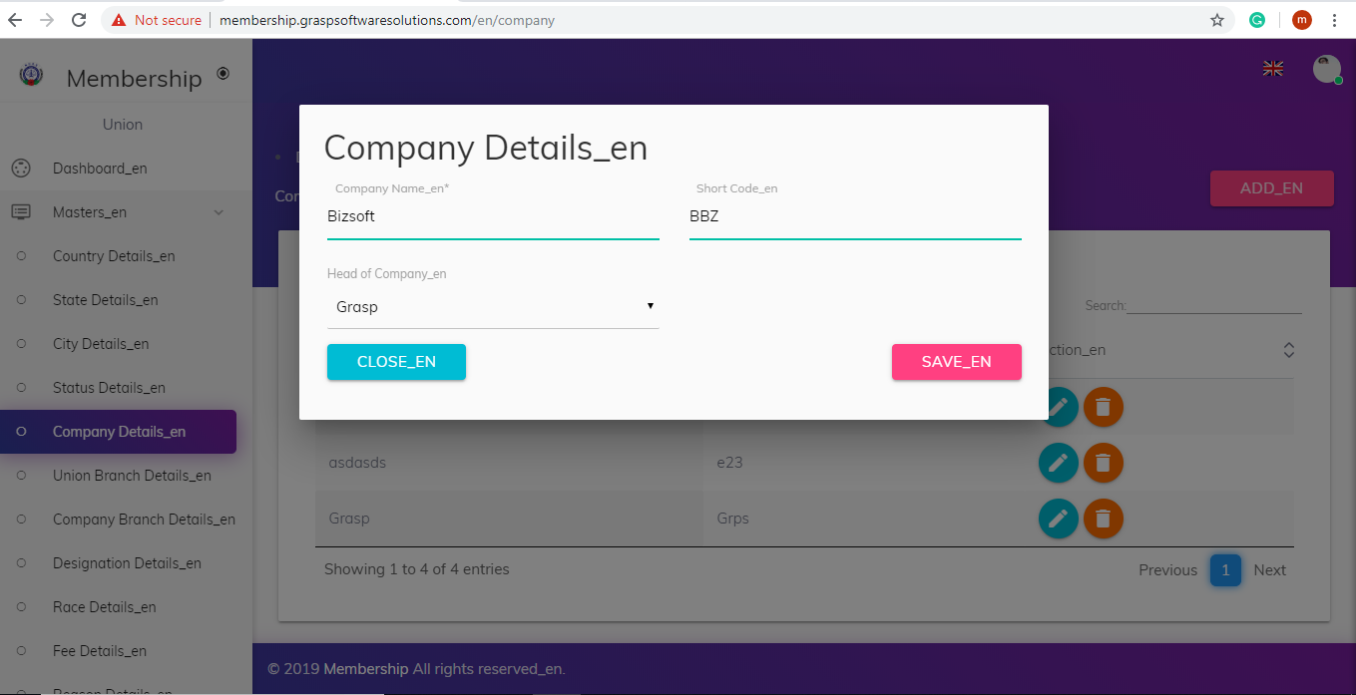

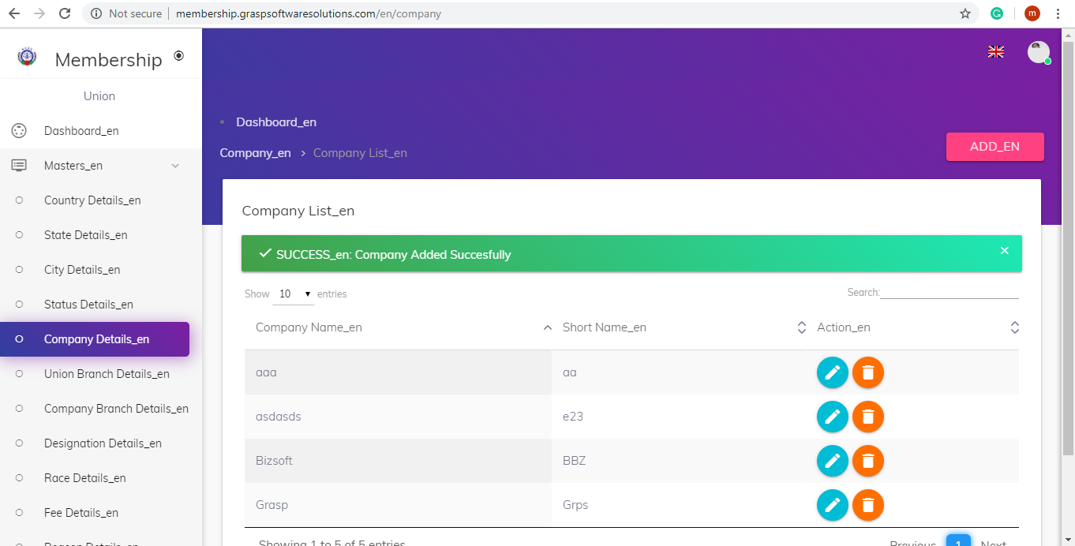

**Company Update and Delete.**

This allows user to update and delete the records as like the Status update and delete

**4. Membership Module**

* UnionRole Login – Registered members are the Active members

* Where as other roles registered members are to be new members (Not activated).

* New members are activated by the Union.

New members and Active members are listed separately. Union can navigate to those lists by button

